**PRACTICAL-3**

**AIM:**

An organization is having 3 braches at 3 different locations. The founder of organization wants to configure the WAN connection amongst all the branches for better communication, file sharing and resource sharing. Demonstrate the static routing configuration for the given scenario using cisco packet tracer.

**THEORY:**

**WAN:**

* A wide area network (also known as WAN), is a large network of information that is not tied to a single location.
* WANs can facilitate communication, the sharing of information and much more between devices from around the world
* WANs are the largest forms of computer networks available to date.

**STATIC ROUTING:**

* Static routing is the manual configuration and selection of a network route, usually managed by the network administrator.
* It is employed in scenarios where the network parameters and environment are expected to remain constant.
* Static routing is only optimal in a few situations.

**PRACTICAL IMPLEMENTATION:**

* As there are 3 different locations, so will form 3 individual networks.

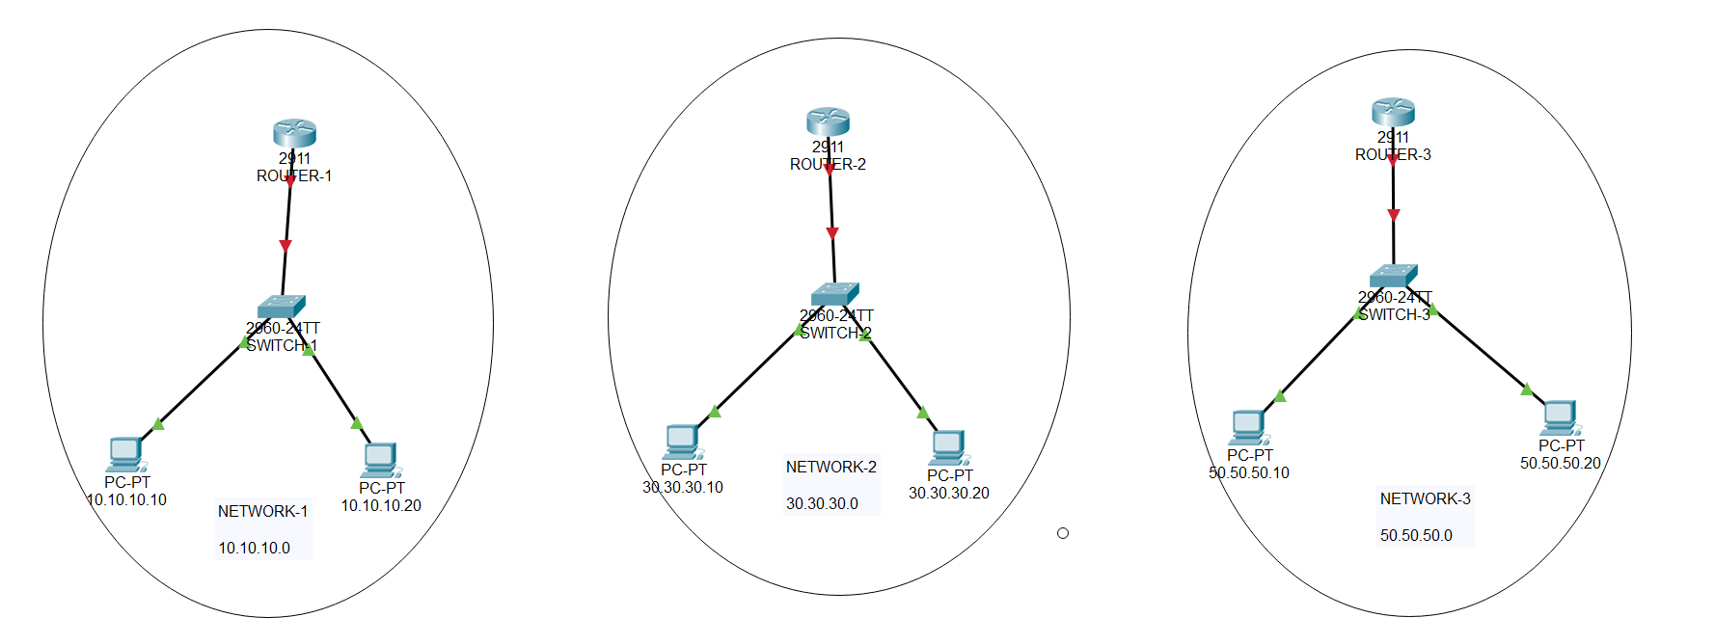

* Now, We will configure the IP address in all PCs.
* To configure IP address, go to PC -> Desktop -> IP configuration

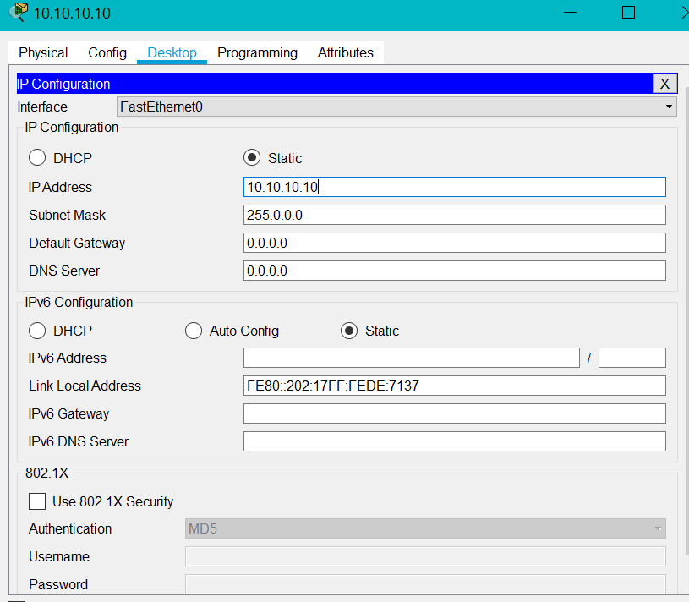

* Perform the same steps for all the PCs.
* To configure the router perform the following steps:

1. Press RETURN to start the session

2. Type enable to get to privileged mode

3. Type config terminal to access the configuration menu.

4. Type interface GigabitEthernet0/0

5. Type ip address xxx.xxx yy.y.yy to assign an IP address and subnet mask to the interface.

6. Type no shutdown to open the interface up for business.

* Perform the same steps for other network.

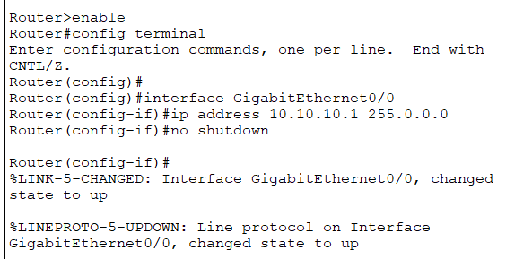

* Follow the same for all the routers.
* Assign default gateway to all the PCs.

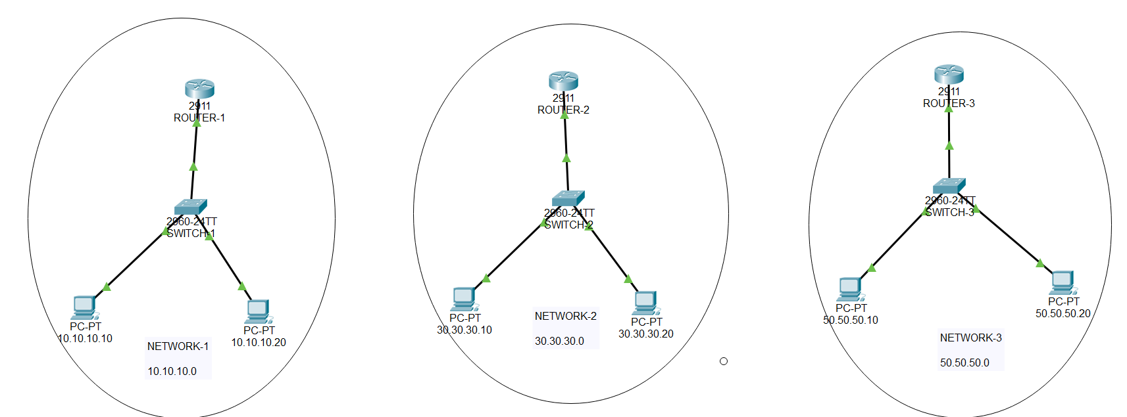

* So, our 3 networks are established.
* Now, we will establish WAN connection so all the 3 networks can communicate with each other.

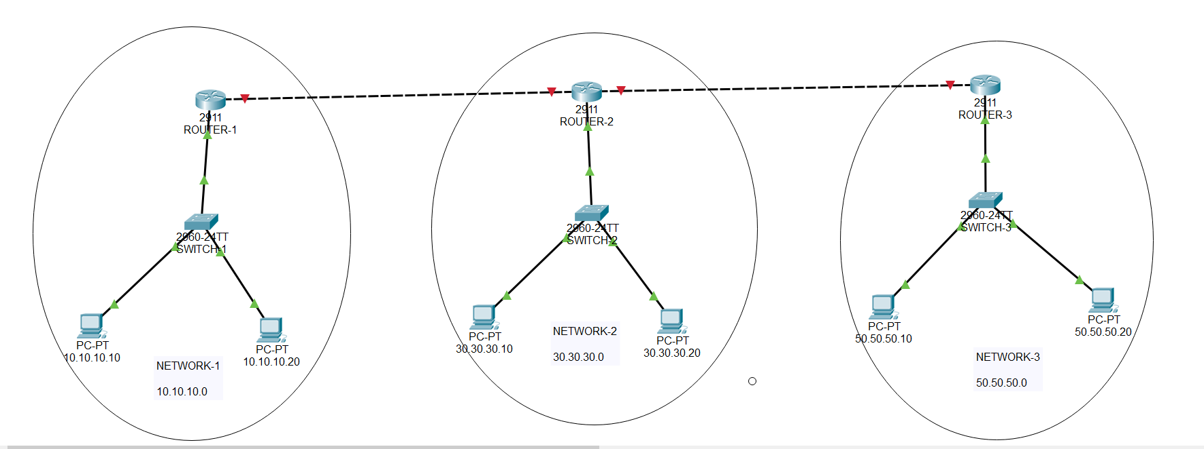

* As seen in the image, we will have to use static routing to establish WAN.
* We will establish a connection between all the routers.
* We will connect Router-1 and Router-2 with network 20.20.20.0 and Router-2 and Router-3 with network 40.40.40.0

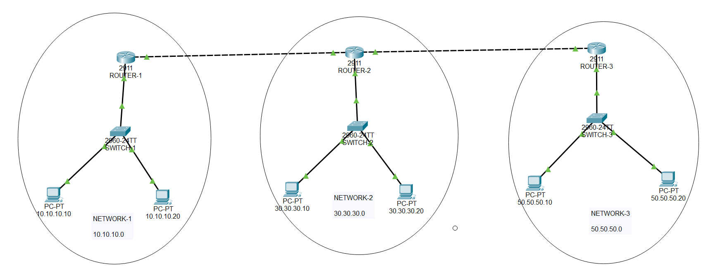

* Upon successful setup, all the arrows will be green indicating an active connection.
* But still Routers can communicate with the networks directed connected to it but they cannot communicate with the networks not directly connected.
* So, we need to define routing table so that routers can communicate.\
* For that we will use static routing.

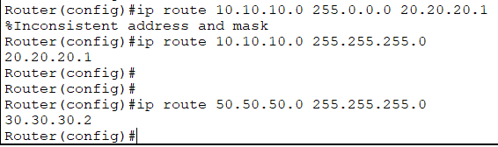

* Perform the steps with all the routers.
* Thus, our WAN is established.

**TESTING:**

* To Test whether the WAN is established or not, we will do PING test.

**NOTE: ROUTER-1 and ROUTER-2 are connected via 20.20.20.0**

**ROUTER-2 and ROUTER-3 are connected via 40.40.40.0**

**ROUTER -1 and ROUTER-3 are connected via 60.60.60.0**

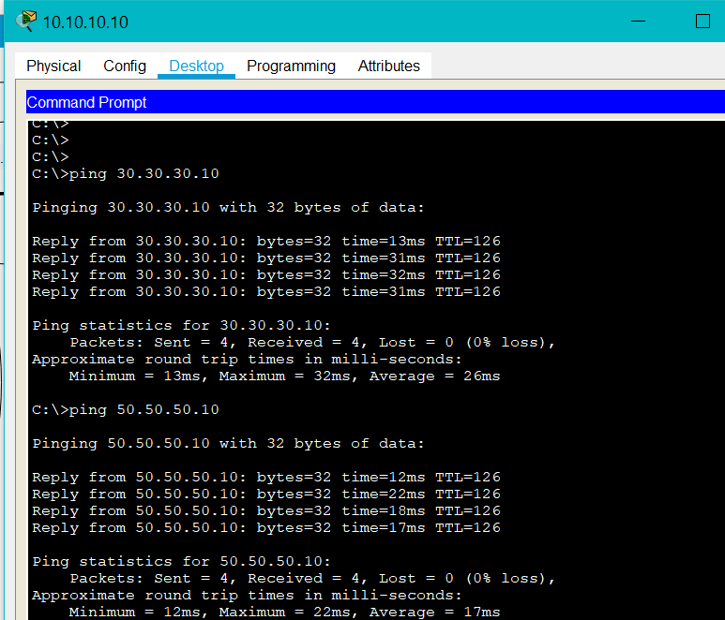

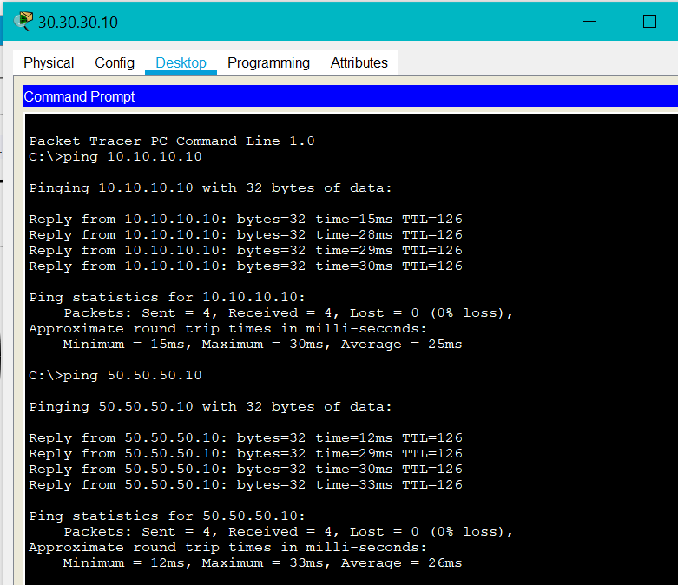

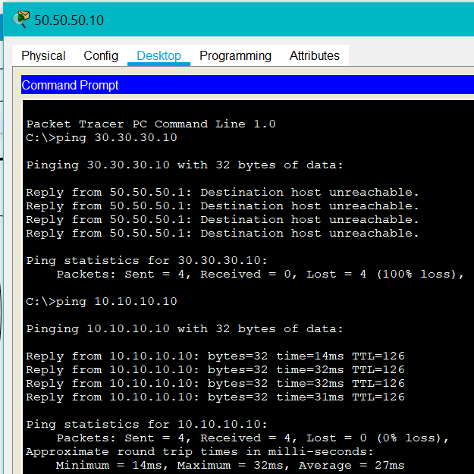

**CONCLUSION:**

* By performing the above Practical, We got to learn about how to configure WAN and also, how WAN and static routing works.